Brazil E-commerce Performance Analysis Report
Dataset: Brazilian E-commerce Dataset
Tools Used: SQL, Tableau
Author: Valeriia Tsentylo

1. Project Overview
The objective of this project was to analyze the performance of a Brazilian e-commerce business, focusing on revenue growth, customer behavior, regional performance, and customer satisfaction drivers.
The analysis aims to identify key growth drivers, operational bottlenecks, and opportunities for business optimization.

2. Business Performance Overview

Key KPIs:
- Total Revenue: ~$1.0M+
- Total Orders: ~6K+
- Average Order Value (AOV): ~$160

Insights:
- The business demonstrates steady growth over time.
- Revenue growth is primarily driven by increasing order volume rather than higher spending per order.
- AOV remains stable, indicating consistent pricing and purchasing behavior.

3. Revenue & Orders Trend Analysis
Revenue and order trends were analyzed on a monthly basis.

Key findings:
- Revenue increased significantly over the analyzed period, indicating strong business growth.
- Order volume closely mirrors revenue trends, suggesting demand-driven growth.
- Peak periods (late 2017–early 2018) indicate possible seasonality or promotional activity.
- No major downturns observed → business is stable and scalable.

Business Insight:
Growth strategy is working, but depends heavily on volume → not margin optimization.
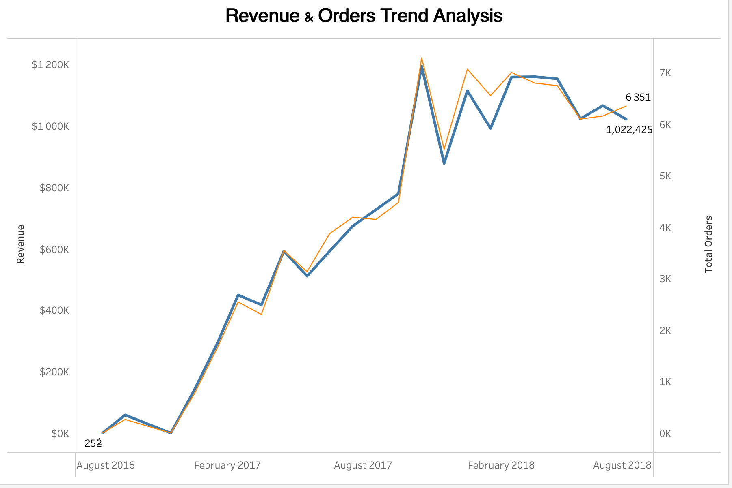

4. Average Order Value (AOV) Analysis

Key findings:
- AOV fluctuates between ~$145–$175, remaining relatively stable.
- A noticeable drop (~$20) in one period indicates incomplete or abnormal data (later excluded).
- No long-term upward trend in AOV.

Business Insight:
Customers are not spending more per order → growth is not value-driven.
This suggests:
- pricing strategy is static
- or lack of upselling / bundling
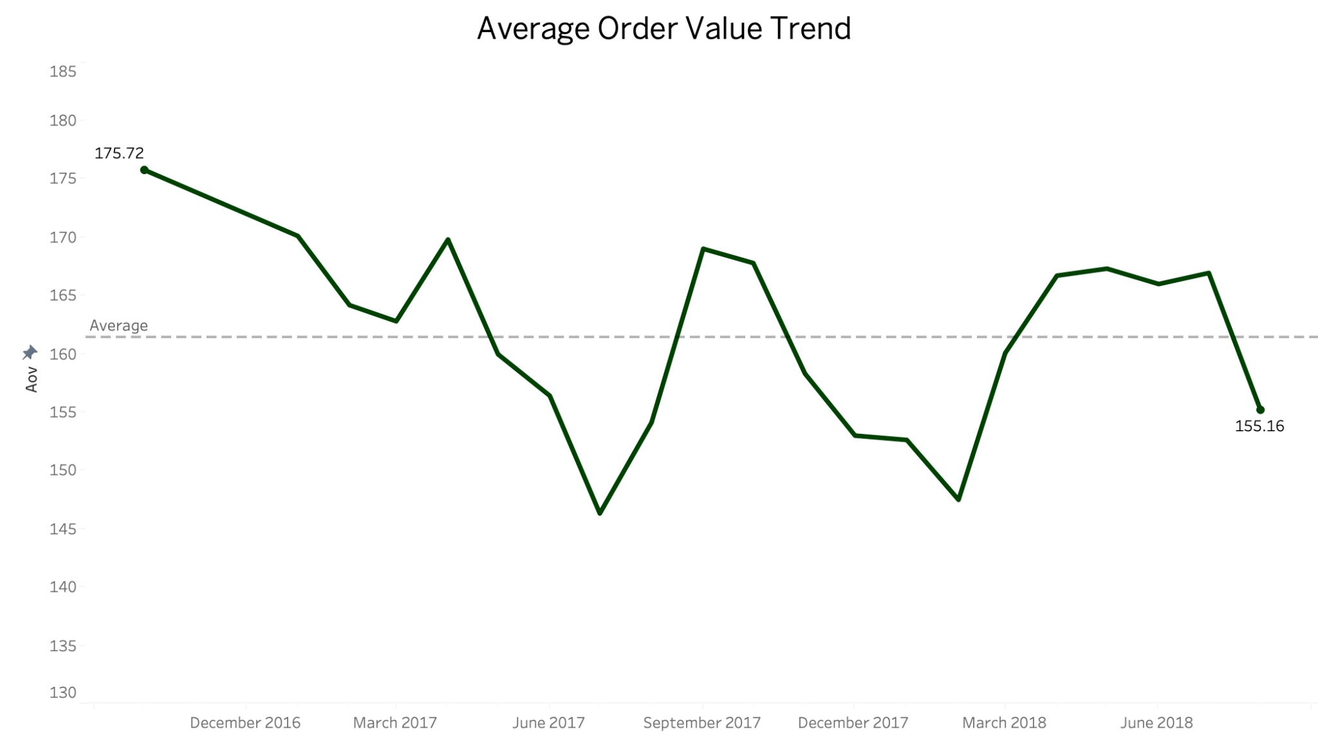

5. Geographic Revenue Analysis
Revenue distribution across Brazilian states shows strong regional concentration.

Key findings:
- São Paulo dominates revenue generation.
- Southeast region contributes the majority of total revenue.
- Other states show significantly lower performance.

Business Insight:
Business is highly dependent on a few regions → risk concentration
Growth opportunity:
- expand logistics & marketing outside core regions
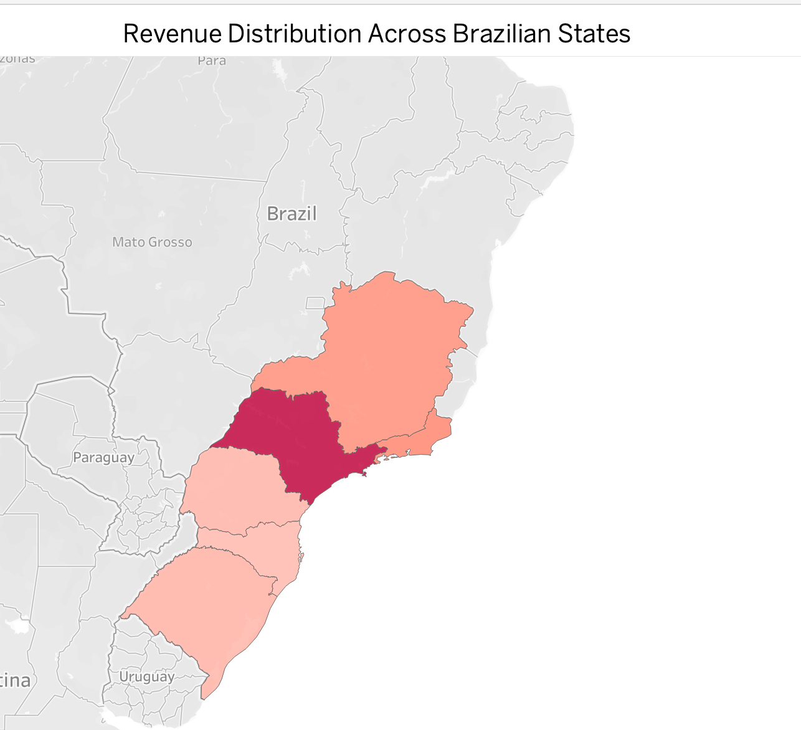

6. Customer Experience Analysis

Key findings:
- Strong negative correlation between delivery time and review score.
- Customers with:
  - ~10 days delivery → rating ~5
  - ~20+ days delivery → rating ~1–2
- Larger bubbles (more reviews) are concentrated at higher ratings.

Business Insight:
Delivery time = critical driver of customer satisfaction
This directly impacts:
- retention
- brand perception
- repeat purchases
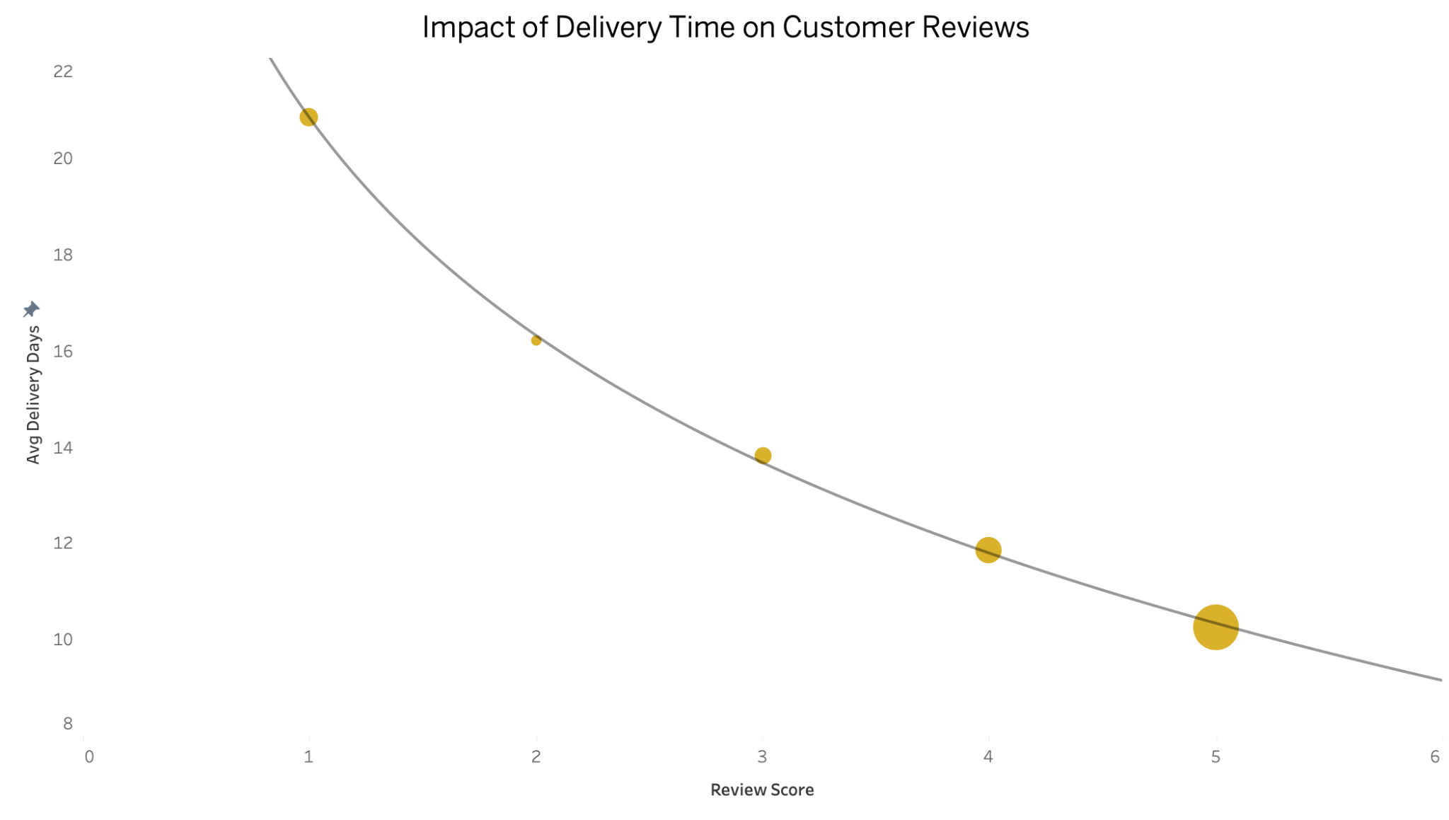

7. Key Business Insights
- Growth is driven by order volume, not customer spending
- AOV stagnation indicates limited monetization per customer
- Revenue is geographically concentrated
- Delivery time strongly impacts reviews
- Customer experience is a key lever for growth

8. Recommendations

Operations
- Reduce delivery time through logistics optimization
- Focus on last-mile delivery improvements

Revenue Growth
- Introduce upselling / bundling strategies
- Encourage higher basket size (discounts on larger carts)

Expansion
- Invest in underperforming regions
- Expand warehouse / delivery coverage

Customer Experience
- Track delivery time as a KPI
- Prioritize fast delivery for high-value customers

Analytics
- Monitor AOV trends
- Segment customers by behavior and region

